**19.2.1**

Jump.Jump.Jump

Benny, you need to stop that.

Why?

You need to stop because Paz is angry.And Mrs Berr is angry.

No, they aren’t.

What are you doing?

I’m doing exercise so I become with strong. Would you like to do exercises with me? Come on . It’s fun.

No, I wouldn’t but I would like to work on my laptop.

I’m not stoping you.

It’s loud.

Would you like me to turn it down?

Yes, I would .Thank you.

Would you like get the door? I’d like to but I’m doing exercises. Jump.Jump.Jump

What is Benny doing?

* He’s exercising.

Why does Shen tell Benny to stop excercising?

* Because Paz and Mrs. Berry are angry

What is Shen trying to do?

* Work on his computer

Why doesn’t Benny turn down the music?

* Because he wants to hear it.

**Practice**

I would like some tea.

I would like to work on my laptop.

Would you like me to turn the music down?

Would you like to go to the movies with me?

Would you like me to get the door?

I’d like to get the door, but I’m doing excercises.

I wouldn’t like to go out dinner tonight.

**Skills Practice**

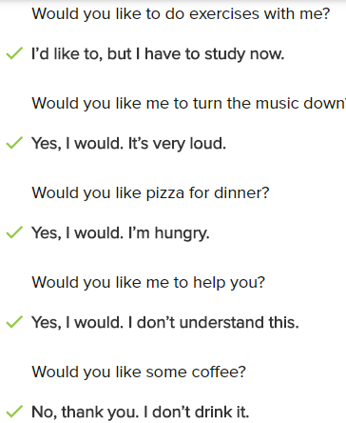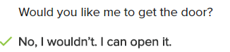

**Conversation**

This is fun. Would you like to do exercises with me?

No,I wouldn’t . But I’d like work on my laptop.

Ok. Would you like me to turn the music down?

Yes, I would. It’s loud.

Ok. Would you like to watch TV later?

No, I wouldn’t. But I’d like to go for walk.

Great. Where would you like to go?

I’d like to go to the park.

Cool. After that, what you want to do?

Would you like to go to the restaurant for dinner?

Sure, That’s good idea.

What time would you like to go?

Can you go at the now?

No, I need to finish my work. I can go at 6.

**Exercise**

The TV is very loud, so I would like you to turn it down.

I’d like to wear jeans to work, I don’t like wearing suits.

Linda: Would you like to go out for dinner?

* Barry: Yes, I would. I’m hungry.

Joe: Can you get the door?

* Sorry, I’m busy.

Sarah: Would you like me to help you?

* Liz: Yes, please. I don’t understand this.

Rick: Would you like to do some exercises with me?

* Ming: Sorry. I want to, but I need to study.

I wouldn’t like coffee, but I’d like some tea.

Yoli: Would you like to go the store?

Vic: Yes, I would. I need some new shoes. When can we go?

19.2.1

Hello Paz!

Hello there, Pazz!

**Hi Shen! How are you?**

**I’m OK, How are you?**

**I’m angry**

Would you like to come in and talk?

No, I like to stand here and talk

**Is there something wrong?**

**Yes, I’d like to get some sleep, but I can’t.** Do you know why?

**Is it because Shen’s laptop is loud?**

**No, It’s because you’re jumping and your music is very loud**

Would you like me to turn the music down?

Yes, please

OK, I can do that

Now! I would like to sleep, No more jumping, no more music

Goodbye Paz!

What?

**I would like an apology**

For what?

**You can turn down the music for Paz, but not for me**

You don’t look like Paz

Yes, but ...I would like in apology

**OK, I’m sorry Shen**

Thank you

Why does Paz come to the door?

-> because she’s angry

Why is Paz angry?

-> because she can’t sheep

Paz can’t sleep because Benny’s music is loud

What does Shen want Benny to do?

-> Say sorry to him

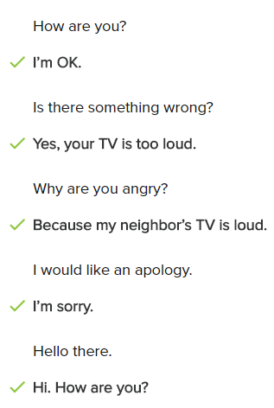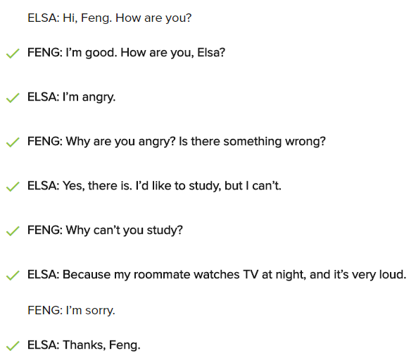

**Conversation**

Hello Paz!

Hi, Benny, how are you?

I’m OK, How are you?

I’m really angry!

Is there something wrong?

Yes, I’d like to get some sleep, but I can’t

Is it because Shen’s laptop is loud?

No, It’s because your music is very loud

What would you like me to do?

I’d like you turn off the music

But I need to do exercise, do you want to exercise with me?

No, I wouldn’t, I’d like to sleep!

OK Paz, I can turn off the music

Thanks, good night, Benny!

**Exercise**

How are you?

-> I’m great

How are you?

-> I’m angry

Is there something wrong?

-> Yes. I’m tires, and I can’t sleep

Would you like to come in and talk?

-> No, thanks. I’m busy right now

Do you know why I’m angry?

-> Is it because your neighbor’s music is loud?

You’re eating my sandwich! I would like an apology

I would like an apology

-> OK, I’m sorry

Why are you so happy?

-> Because I have a new job. I love it!

My boss fired me

-> That’s terrible!

We can wear jeans to work on Fridays now!

-> Very cool!

19.1.3

Oh, an email from Marti!

Shen baby, it’s you agent, Marti! I have some thing important to tell you, we need to talk on the phone! Answer my call! Thank you Marti

Marti want to talk on the phone

When?

Hello

Who is this?

This is Shen

Shen! Shen baby, **It’s Marti, Marti Blum, your agent! How are you?**

Marti, Hello. **I’m very good. How are you?**

I’m good. **I’m calling because I have good news for you.** **Would you like to here ?**

Yes

**I have a job for you**

**That’s great!** What’s a job?

A adults man

A adults man? What’s that?

It’s easy! It stand in font of the door and tell people they can go inside a building

Is there a script?

No, but there is a little name, be have to learn the names

OK, I can do that, put on the list

A lot of people

Is Dan Blaze on it?

Yes, he is

I work with Dan Blaze?

**The job starts tomorrow night,** I can email you information. **Good luck Shen baby**

**Thank you Marti**, thank you!...Marti have a job for me! I work with Dan Blaze

That’s amazing

Open the door, Benny! I know you are in tthere

Shen gets an email from Marti

What is Marti’s good news?

-> She has a job for Shen

What does Shen need to do for the job?

-> Tell people they can go in a building

What does Shen need to leearn for the job?

-> Names on a list

When does the job start?

-> Tomorrow

**Conversation**

Hello Sam!

Hi, who's this?

It's Dina, your agent. How are you?

I'm very good. How are you?

I'm fine, thanks. I calling because I have some good news. Do you want to hear?

Yes, what's the news?

I have a job for you

That's great. What's the job?

An actor in a movie

That's amagzing. Is there a script?

Yes, there is. But you only have to learn a few words

OK, I can do that

You start tomorrow afternoon. Good luck Sam

Thank you.

**Excercise**

I have some great news. Would you like to hear it?

I have a job for you.

* That’s great. What is it?

I can’t come to the restaurant for your birthday.

* I’m sorry you can’t be there.

You have to clean the tables every night.

* I can do that.

I have a job for you as a salesperson.

* A salesperson? Where?

Good luck with the job.

* Thank you!

Hello. Could you tell me your name?

* It’s Jenna.

**Lesson Exercise**

What would you like to do tonight?

--> Let's go to the movies

Could I get you something to drink?

--> Sure. I'd love a soda, please

Do you speak Freanch?

--> Yes, I can speak Freanch

Would you like something to eat?

--> Sure. Can I have a sandwich?

Would I give you an apple?

--> Sure. I can get it for you

Would you like to ride my horse?

--> No, thank you. I'm scared of horses

Would you like me to get your laundry out of the dryer for you?

--> Yes, please. I need some clean clothes to wear to work this morning

What would you like to do on this rainy day?

--> I don't want go outside. I think I'd like to stay inside and watch TV

I'd like to take a vacation to Brazil. What about you?

--> Yes, I'd like to, too. It's an exciting place with great food.

Hi Sam. How are you?

Not great, Bath

What's wrong? You don't look happy at all

Well. I have a new boss, and he's very mean

I'm so sorry. Maybe you need to find a new job

You're right!

Hello? Who is this?

--> It's me, Mira, your new neighbor

Sorry, I'm busy now, Matt. Can i call you back later?

--> Sure. You have my number.

Hello, Libby. Would you like to hear the bad news or the good news first?

--> Hello Alice. Tell me the good news first!

I'm calling because I need to see you in my office again soon

--> Oh, really? Why do you need to see me?

Hello , John?I have some good news. I have an amazing new job!

You have a new job? That’s great. When does it start?

**1/8**

1 Shen: What’s wrong, Paz?

Paz: I can't get any sleep.

2 Mari: How are you, Shen?

Shen: I'm great.

3 Benny: Would you like a cup of coffee?

Paz: No, thank you. I'd like to go to sleep.

4 Shen: Do you know why I’m happy?

Benny: Is it because you have a new job?

5 Shen: Shen, baby. I have a job for you.

Marti: I’m great, Shen. Thank you.

6 Marti: How are you, Marti?

Shen: Really? What is it?

7 Paz: Benny, I am really angry.

Benny: Is it because Shen's laptop is too loud?

8 Marti: I have great news for you, Shen.

Shen: Really? I would like to hear it.

**2/8**

1 Dan wants a cup of tea.

Dan would like a cup of tea.

2 He wants some sugar in his tea.

He would like some sugar in his tea.

3 George and Holly want some tea too.

George and Holly would like some tea too.

4 Bruce wants to listen to music.

Bruce would like to listen to music.

5 His roommate wants to sleep.

His roommate would like to sleep.

6 I want to live in New York.

I would like to live in New York.

7 I want to take acting classes there.

I would like to take acting classes there.

8 They want to thank you for your help.

They would like to thank you for your help.

9 They want to cook dinner for you.

They would like to cook dinner for you.

**3/8**

1 Would you like to see a movie?

2 I would like some soup.

3 They would like to come to the party.

4 She would like a new dress.

5 Would you like to go to the gym with me?

6 He would like some sugar in his coffee.

7 They would like to sleep.

8 I would like to watch TV.

9 Would he like to play a game?

10 She would like to have some coffee.

**4/8**

1 Shen wants to work on his laptop.

--> Shen would like to work on his laptop.

2 Shen, do you want to do exercises with me?

--> Shen, would you like to do exercises with me?

3 Benny wants to get the door, but he’s doing exercises.

--> Benny would like to get the door, but he’s doing exercises.

4 Paz doesn’t want to come in and talk.

--> Paz wouldn't like to come in and talk.

5 Paz wants to get some sleep, but she can’t.

--> Paz would like to get some sleep, but she can’t.

6 Shen wants an apology.

--> Shen would like an apology.

**5/8**

Would you like to see what I'm working on?

--> I would like to work on my laptop.

Would you like to do exercises with me?

-->I would, but I have to do homework now.

Would you like me to turn the music down?

-->Yes. It's very loud.

Would you like to get the door?

-->I'd like to, but I'm busy exercising.

Would you like some chicken?

-->Yes, I would. I'm hungry.

Would you like some help?

-->Yes, please. I don't understand this sentence.

**6/8**

Mary: Hello. This is Mary Hartman.

Shen: Hello, Mary. It's Shen. How are you?

Mary: I'm great, Shen.

Shen: Mary, I have great news. Would you like to hear it?

Mary: Yes, please tell me.

Shen: I have an acting job!

Mary: I'm very happy to hear it, Shen. What is the job?

Shen: I'm a doorman.

Mary: That's sounds great! Do you have a script?

Shen: I don't have a script, but I have to remember a lot of names. And Dan Blaze is in the movie, too!

Mary: Dan Blaze? That's awesome, Shen!

**7/8**

**Conversation 1**

Yin: Hi, Lu. How are you?

Lu: I'm very angry.

Yin: Is something wrong?

Lu: Yes. My new shirt is dirty.

**Conversation 2**

Jason: Hi, Sheila. How are you?

Sheila: Hi, Jason. I'm angry

Jason: I’m sorry. Why are you angry?

Sheila: I would like to sleep, but your music is too loud

Jason: I’m sorry, Sheila. Would you like me to turn it down?

Sheila: Yes, please. Thank you, Jason.

**8/8**

Jun: Hello, Allie. This is Jun. How are you?

Allie: Hello, Jun. I’m good. And how are you?

Jun: I’m great, thank you.I have some great news.

Allie: Please, tell me. I would like to hear it.

Jun: Dan got a new job!

Allie: That’s great news, Jun. What is the job?

Jun: A teacher.

Allie: I’m very happy for him.

Jun: Listen, we want to have a party for him. Would you like to come?

Allie: Yes, we would love to come.

Jun: That’s great!

Allie: When is the party?

Jun: It’s on Saturday.

Allie: Would you like me to bring anything?

Jun: No. You don’t need to bring anything.

Allie: Great. See you soon.

**Jun:** Yes. See you soon.